16.31: a) For constructive interference, the path difference 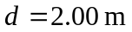must be equal to an integer multiple of the wavelength, so 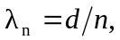

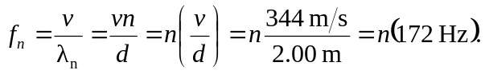

Therefore, the lowest frequency is 172 Hz.
b) Repeating the above with the path difference an odd multiple of half a wavelength, 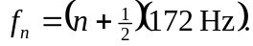Therefore, the lowest frequency is 